38. Scenario: You work for a weather data analysis company, and your team is responsible for

developing a program to calculate and analyze variability in temperature data for different cities.

Question: Write a python program will take in a dataset containing daily temperature readings for

each city over a year and perform the following tasks:

1. Calculate the mean temperature for each city.

2. Calculate the standard deviation of temperature for each city.

3. Determine the city with the highest temperature range (difference between the highest and

lowest temperatures).

4. Find the city with the most consistent temperature (the lowest standard deviation).

Code:

**import** pandas **as** pd

*# Load the dataset*

df **=** pd.read_csv(r"C:\Users\jampa\Downloads\city_temperature_data.csv")

*# Group by city and calculate required statistics*

summary **=** df.groupby('City').agg(

Mean_Temperature**=**('Temperature', 'mean'),

Std_Deviation**=**('Temperature', 'std'),

Max_Temperature**=**('Temperature', 'max'),

Min_Temperature**=**('Temperature', 'min')

)

*# Calculate the temperature range*

summary['Temperature_Range'] **=** summary['Max_Temperature'] **-** summary['Min_Temperature']

*# Find the city with the highest temperature range*

highest_range_city **=** summary['Temperature_Range'].idxmax()

*# Find the city with the most consistent temperature (lowest std deviation)*

most_consistent_city **=** summary['Std_Deviation'].idxmin()

*# Display results*

print("=== Temperature Summary by City ===")

print(summary)

print("\nCity with the Highest Temperature Range:", highest_range_city)

print("City with the Most Consistent Temperature:", most_consistent_city)

Output:

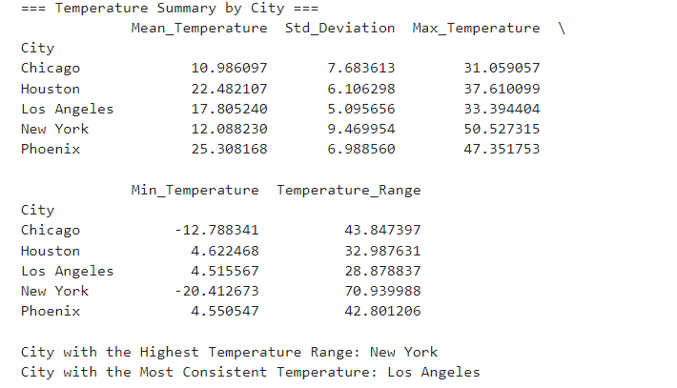

Dataset:

|  |  |  |
| --- | --- | --- |
| Date | City | Temperature |
| 1/1/2024 | New York | 16.96714 |
| 1/2/2024 | New York | 10.61736 |
| 1/3/2024 | New York | 18.47689 |
| 1/4/2024 | New York | 27.2303 |
| 1/5/2024 | New York | 9.658466 |
| 1/6/2024 | New York | 9.65863 |
| 1/7/2024 | New York | 27.79213 |
| 1/8/2024 | New York | 19.67435 |
| 1/9/2024 | New York | 7.305256 |
| 1/10/2024 | New York | 17.4256 |
| 1/11/2024 | New York | 7.365823 |
| 1/12/2024 | New York | 7.342702 |
| 1/13/2024 | New York | 14.41962 |
| 1/14/2024 | New York | -7.1328 |
| 1/15/2024 | New York | -5.24918 |
| 1/16/2024 | New York | 6.377125 |
| 1/17/2024 | New York | 1.871689 |
| 1/18/2024 | New York | 15.14247 |
| 1/19/2024 | New York | 2.919759 |
| 1/20/2024 | New York | -2.12304 |
| 1/21/2024 | New York | 26.65649 |
| 1/22/2024 | New York | 9.742237 |
| 1/23/2024 | New York | 12.67528 |
| 1/24/2024 | New York | -2.24748 |
| 1/25/2024 | New York | 6.556173 |
| 1/26/2024 | New York | 13.10923 |
| 1/27/2024 | New York | 0.490064 |
| 1/28/2024 | New York | 15.75698 |
| 1/29/2024 | New York | 5.993613 |
| 1/30/2024 | New York | 9.083063 |
| 1/31/2024 | New York | 5.982934 |
| 2/1/2024 | New York | 30.52278 |
| 2/2/2024 | New York | 11.86503 |
| 2/3/2024 | New York | 1.422891 |
| 2/4/2024 | New York | 20.22545 |
| 2/5/2024 | New York | -0.20844 |
| 2/6/2024 | New York | 14.08864 |
| 2/7/2024 | New York | -7.5967 |
| 2/8/2024 | New York | -1.28186 |
| 2/9/2024 | New York | 13.96861 |
| 2/10/2024 | New York | 19.38467 |
| 2/11/2024 | New York | 13.71368 |
| 2/12/2024 | New York | 10.84352 |
| 2/13/2024 | New York | 8.988963 |
| 2/14/2024 | New York | -2.78522 |
| 2/15/2024 | New York | 4.801558 |
| 2/16/2024 | New York | 7.393612 |
| 2/17/2024 | New York | 22.57122 |
| 2/18/2024 | New York | 15.43618 |
| 2/19/2024 | New York | -5.6304 |